SUMMER TRAINING/INTERNSHIP REPORT
(Term Aug-Dec 2026)

Submitted by
Keshav kumar Registration Number : 12417846
Karan Singh Registration Number :12408265
Yuvraj Yadav Registration Number : 12410162
Priyanshu Kumar Registration Number : 12410036

Under the Guidance of
Gaurav Sharma

School of Computer Science and Engineering



WORD LADDER / SHORTEST TRANSFORMATION PATH FINDER

DECLARATION:
We hereby declare that the summer training/internship project report entitled "Word Ladder / Shortest Transformation Path Finder" submitted by us to the Department of Computer Science & Engineering & Information Technology, is an authentic record of our own joint work.
The matter embodied in this report has not been submitted or copied from any other source for the award of any other degree or diploma.
Date : 17/07/2026
CERTIFICATE:
This is to certify that the Summer Training/Internship report entitled "Word Ladder / Shortest Transformation Path Finder" is a bona fide record of the project work carried out jointly by Keshav kumar, Karan Singh, Yuvraj Yadav, and Priyanshu Kumar under my supervision and guidance. The students have successfully completed the project matching the required standard objectives.

ACKNOWLEDGEMENT:
We express our deep sense of gratitude to our project mentor, Gaurav Sharma , for providing valuable online guidance, constant encouragement, and immense virtual support throughout the development of this project.
We are also thankful to the Head of the Department and the institution for providing the necessary digital facilities, cloud computing infrastructure, and a highly encouraging remote environment that helped us complete our online training successfully.

1. INTRODUCTION & ORGANIZATION
This training report outlines the development of a software-based problem-solving engine called the Word Ladder / Shortest Transformation Path Finder. Developed within the Puzzle/Game-based Learning hackathon theme, the project aims to bridge advanced data structure concepts with practical gamified applications.
The primary organization behind this framework focuses on building algorithmic optimization tools for academic and recreational puzzle-solving architectures. By abstracting word patterns into discrete network elements, this system shows how foundational graph methodologies solve complex linguistic constraints.

2. SUMMER TRAINING COURSE/INTERNSHIP CONTENT DETAIL
During the training period, a deep-dive study into algorithmic engineering was conducted. The primary focus remained on intermediate and advanced data structures using modern C++ principles. The structural content learned and practiced includes:
- Graph Theory Foundations: Understanding vertices, edges, directed/undirected graphs, and representing structural configurations using adjacency lists.
- Graph Traversal Algorithms: Mastering Layer-by-Layer exploration mechanics via Breadth-First Search (BFS) to identify structural minimums.
- Hashing and Lookup Optimizations: Implementing memory-efficient collision handling and $O(1)$ constant time lookup sets for expansive vocabularies.
- Space-Time Complexity Analysis: Evaluating algorithm memory limits and optimizing execution steps for real-time applications.

3. SUMMER TRAINING/INTERNSHIP PROJECT DETAIL

3.1 Problem Statement
Given a start word, a target word, and a dictionary containing a comprehensive list of valid words, find the shortest sequence of single-letter transformations required to change the start word into the target word. Each consecutive intermediate step in the transformation path must correspond to a valid dictionary word.

3.2 Project Outcomes
- Implicit Graph Modeling: Successfully modeled word transformations as an implicit unweighted graph structure where valid single-letter mutations establish the edges between vertex representations.
- Shortest Path Determination: Applied Breadth-First Search (BFS) to efficiently guarantee the absolute shortest mutation path through the dictionary space.
- High-Speed Lookups: Integrated chaining hashing architectures to reinforce $O(1)$ time complexity verification checks for vocabulary validity during path expansion steps.

3.3 Technologies Used
- Programming Language: C++ (Standard Template Library)
- Core Algorithms: Breadth-First Search (BFS), Graph Traversal
- Data Structures: std::unordered_set (Hash-based dictionary lookup), std::queue (BFS frontier tracking), std::unordered_map (Parent pointer tracking for path reconstruction)
4. SOURCE CODE
#include <iostream>
#include <fstream>
#include <string>
#include <unordered_set>
#include <unordered_map>
#include <queue>
#include <vector>
#include <algorithm>
#include <cctype>

using namespace std;

// ANSI escape codes for coloring terminal text
const string RESET = "\033[0m";
const string BOLD = "\033[1m";
const string RED = "\033[31m";
const string GREEN = "\033[32m";
const string YELLOW = "\033[33m";
const string BLUE = "\033[34m";
const string MAGENTA = "\033[35m";
const string CYAN = "\033[36m";

class WordLadderGame {
private:
unordered_set<string> dictionary;

// Helper to convert string to lowercase for uniformity
string toLower(const string& s) {
string lowerStr = s;
for (char& c : lowerStr) {
c = tolower(c);
}
return lowerStr;
}

// Helper to check if two words differ by exactly one letter
bool isOneLetterDifference(const string& word1, const string& word2) {
if (word1.length() != word2.length()) return false;
int diffCount = 0;
for (size_t i = 0; i < word1.length(); ++i) {
if (word1[i] != word2[i]) {
diffCount++;
if (diffCount > 1) return false;
}
}
return diffCount == 1;
}

public:
// Load words from a text file into the hash set
bool loadDictionary(const string& filename) {
ifstream file(filename);
if (!file.is_open()) {
cout << RED << "Error: Could not open dictionary file '" << filename << "'." << RESET << endl;
return false;
}

string word;
while (file >> word) {
// Only add lowercase words (and strip trailing whitespace if any)
dictionary.insert(toLower(word));
}
file.close();
return true;
}

bool isValidWord(const string& word) {
return dictionary.find(toLower(word)) != dictionary.end();
}

size_t getDictionarySize() const {
return dictionary.size();
}

// The BFS Algorithm to find the shortest path
vector<string> findShortestPath(const string& start, const string& target, bool visualize = false) {
string s = toLower(start);
string t = toLower(target);

if (s == t) return {s};
if (!isValidWord(s) || !isValidWord(t)) return {};

queue<string> q;
q.push(s);

// Keep track of visited words and their parent to reconstruct the path
unordered_map<string, string> parentMap;
parentMap[s] = "";

if (visualize) {
cout << YELLOW << "\n--- Starting Breadth-First Search (BFS) ---" << RESET << endl;
cout << "We use a queue to explore level by level." << endl;
cout << "Pushing start word: " << GREEN << s << RESET << endl;
}

bool found = false;
int level = 0;

while (!q.empty() && !found) {
int levelSize = q.size();
level++;

if (visualize) {
cout << "\n" << BOLD << CYAN << "[Level " << level << "]" << RESET << " Exploring " << levelSize << " word(s)..." << endl;
}

// Process all nodes at the current level
for (int i = 0; i < levelSize; ++i) {
string curr = q.front();
q.pop();

// Generate all possible valid next words
string temp = curr;
for (size_t j = 0; j < temp.length(); ++j) {
char originalChar = temp[j];

// Try replacing with every other letter a-z
for (char c = 'a'; c <= 'z'; ++c) {
if (c == originalChar) continue;

temp[j] = c;

// O(1) lookup using unordered_set
if (isValidWord(temp) && parentMap.find(temp) == parentMap.end()) {
parentMap[temp] = curr; // Record where we came from

if (temp == t) {
found = true;
break;
}

q.push(temp);
}
}
temp[j] = originalChar; // Restore for next iteration
}
if (found) break;
}
}

if (visualize) {
if (found) cout << GREEN << "\nPath found! Reconstructing from target to start using parent map." << RESET << endl;
else cout << RED << "\nQueue empty. No path exists." << RESET << endl;
}

if (!found) return {}; // No path found

// Reconstruct path
vector<string> path;
string curr = t;
while (curr != "") {
path.push_back(curr);
curr = parentMap[curr];
}
reverse(path.begin(), path.end());
return path;
}

void playGame() {
cout << BOLD << CYAN << "\n=== Interactive Game Mode ===" << RESET << endl;
string start, target;

cout << "Enter Start Word (4 letters): ";
cin >> start;
cout << "Enter Target Word (4 letters): ";
cin >> target;

start = toLower(start);
target = toLower(target);

if (start.length() != 4 || target.length() != 4) {
cout << RED << "Please enter 4-letter words." << RESET << endl;
return;
}
if (!isValidWord(start)) {
cout << RED << "'" << start << "' is not in the dictionary!" << RESET << endl;
return;
}
if (!isValidWord(target)) {
cout << RED << "'" << target << "' is not in the dictionary!" << RESET << endl;
return;
}

// Validate that a path actually exists before they play!
vector<string> shortest = findShortestPath(start, target, false);
if (shortest.empty()) {
cout << RED << "Sorry, there is no valid path between '" << start << "' and '" << target << "'." << RESET << endl;
return;
}

cout << YELLOW << "\nGoal: Transform " << GREEN << start << YELLOW << " to " << GREEN << target << YELLOW << "." << RESET << endl;
cout << "Optimal path length is " << shortest.size() << " words." << endl;
cout << "Enter 'quit' to give up." << endl;

string currentWord = start;
int steps = 1;

while (currentWord != target) {
cout << "\nCurrent Word: " << BOLD << currentWord << RESET << " (Step " << steps << ")" << endl;
cout << "Next word: ";
string nextWord;
cin >> nextWord;

nextWord = toLower(nextWord);

if (nextWord == "quit") {
cout << RED << "You gave up!" << RESET << endl;
return;
}

if (nextWord.length() != currentWord.length()) {
cout << RED << "Length must match the current word!" << RESET << endl;
continue;
}

if (!isOneLetterDifference(currentWord, nextWord)) {
cout << RED << "You can only change EXACTLY ONE letter at a time." << RESET << endl;
continue;
}

if (!isValidWord(nextWord)) {
cout << RED << "'" << nextWord << "' is not a valid dictionary word." << RESET << endl;
continue;
}

currentWord = nextWord;
steps++;
}

cout << BOLD << GREEN << "\n🎉 Congratulations! You reached '" << target << "' in " << steps << " steps!" << RESET << endl;
if (steps == shortest.size()) {
cout << MAGENTA << "PERFECT! You found the optimal path!" << RESET << endl;
} else {
cout << "The optimal path was " << shortest.size() << " steps." << endl;
}
}

void solveAndLearn() {
cout << BOLD << MAGENTA << "\n=== Auto-Solve & Learn Mode ===" << RESET << endl;
string start, target;

cout << "Enter Start Word (4 letters): ";
cin >> start;
cout << "Enter Target Word (4 letters): ";
cin >> target;

start = toLower(start);
target = toLower(target);

if (!isValidWord(start) || !isValidWord(target)) {
cout << RED << "Both words must be valid dictionary words." << RESET << endl;
return;
}

cout << YELLOW << "\n[Educational Note]" << RESET << endl;
cout << "We are modeling this as an unweighted graph where:" << endl;
cout << " - Nodes = Dictionary Words" << endl;
cout << " - Edges = Words that differ by exactly 1 letter" << endl;
cout << "Because all edges have a weight of 1, Breadth-First Search (BFS) is guaranteed to find the shortest path." << endl;
cout << "Checking if a word is valid takes O(1) time thanks to std::unordered_set hashing!" << endl;

vector<string> path = findShortestPath(start, target, true);

if (path.empty()) {
cout << RED << "\nNo transformation sequence exists." << RESET << endl;
} else {
cout << BOLD << GREEN << "\nShortest Path Found (" << path.size() << " steps):" << RESET << endl;
for (size_t i = 0; i < path.size(); ++i) {
cout << path[i];
if (i < path.size() - 1) cout << " -> ";
}
cout << endl;
}
}
};

int main() {
WordLadderGame game;
cout << BOLD << CYAN << "Loading dictionary..." << RESET << endl;

// We expect a words.txt file in the same directory
if (!game.loadDictionary("words.txt")) {
return 1;
}

cout << GREEN << "Loaded " << game.getDictionarySize() << " words successfully!" << RESET << endl;

int choice;
do {
cout << "\n" << BOLD << "=== Word Ladder Main Menu ===" << RESET << endl;
cout << "1. Play Interactive Game" << endl;
cout << "2. Auto-Solve & Learn Mode (BFS Visualizer)" << endl;
cout << "3. Exit" << endl;
cout << "Select an option: ";
if (!(cin >> choice)) {
cin.clear();
cin.ignore(10000, '\n');
continue;
}

switch (choice) {
case 1:
game.playGame();
break;
case 2:
game.solveAndLearn();
break;
case 3:
cout << "Goodbye!" << endl;
break;
default:
cout << RED << "Invalid choice." << RESET << endl;
}
} while (choice != 3);

return 0;
}

5. SYSTEM SNAPSHOTS

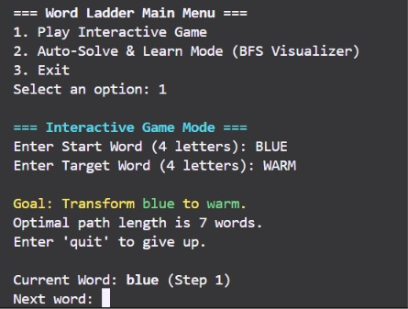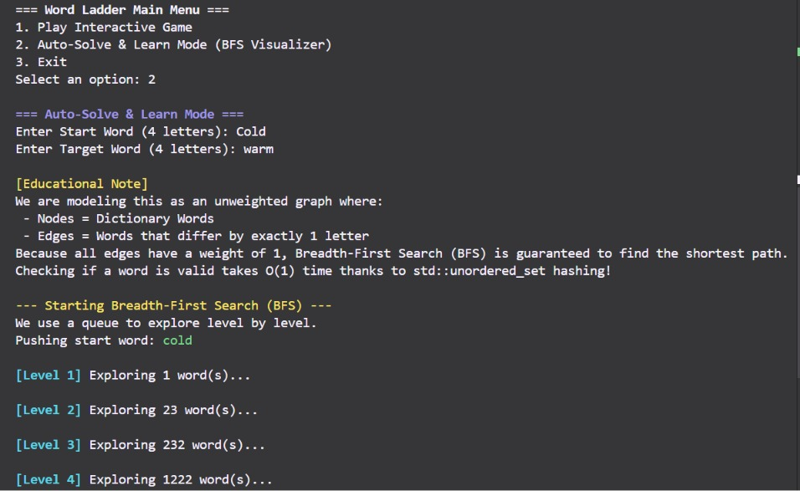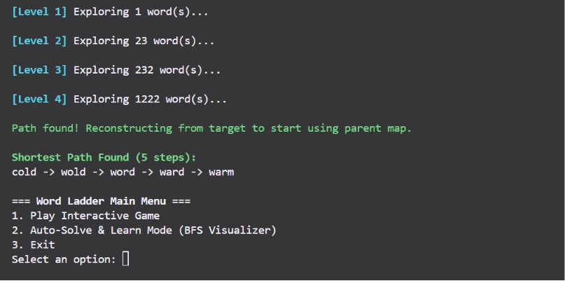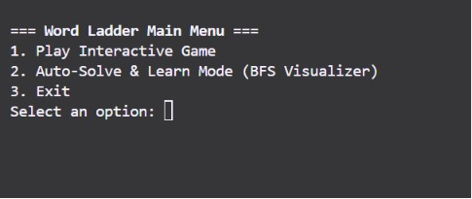

6. BIBLIOGRAPHY
- Stroustrup, B. (2013). The C++ Programming Language (4th ed.). Addison-Wesley.
- Cormen, T. H., Leiserson, C. E., Rivest, R. L., & Stein, C. (2009). Introduction to Algorithms (3rd ed.). MIT Press.
- Sedgewick, R., & Wayne, K. (2011). Algorithms (4th ed.). Addison-Wesley Professional.

